**CAVIEW - Tape to Disk conversion**

Step 1:

To check the production sysout, Give p.3

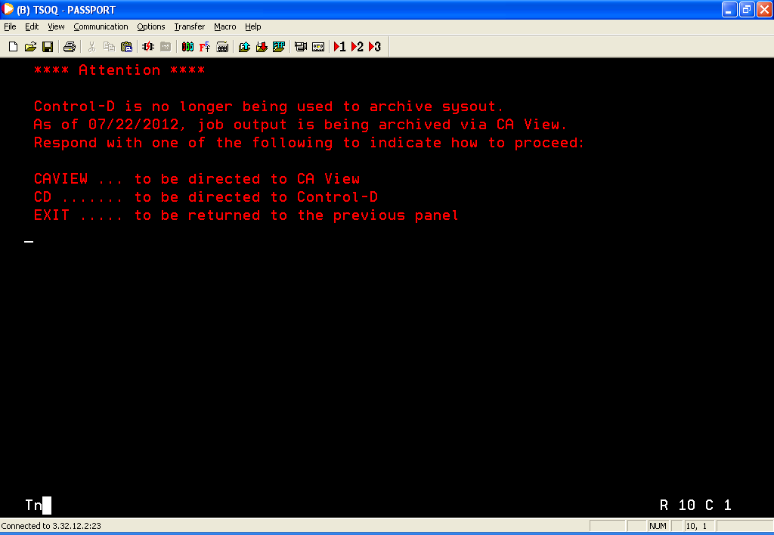

Step 2:

Give CAVIEW and press ‘ENTER’

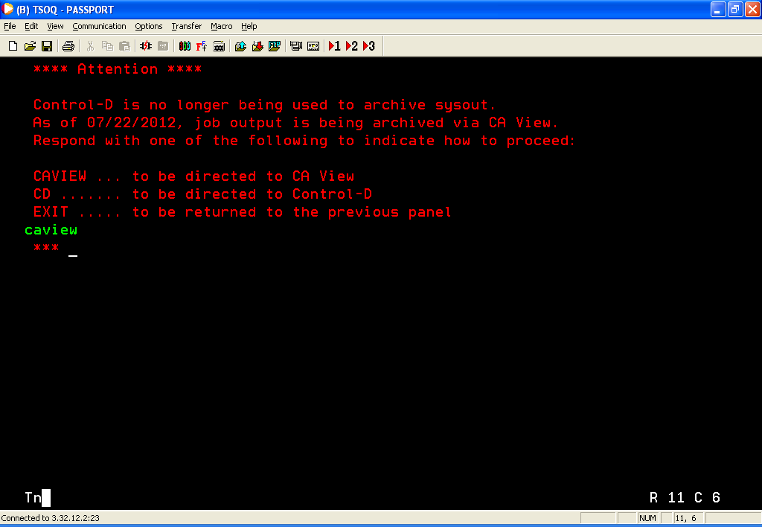

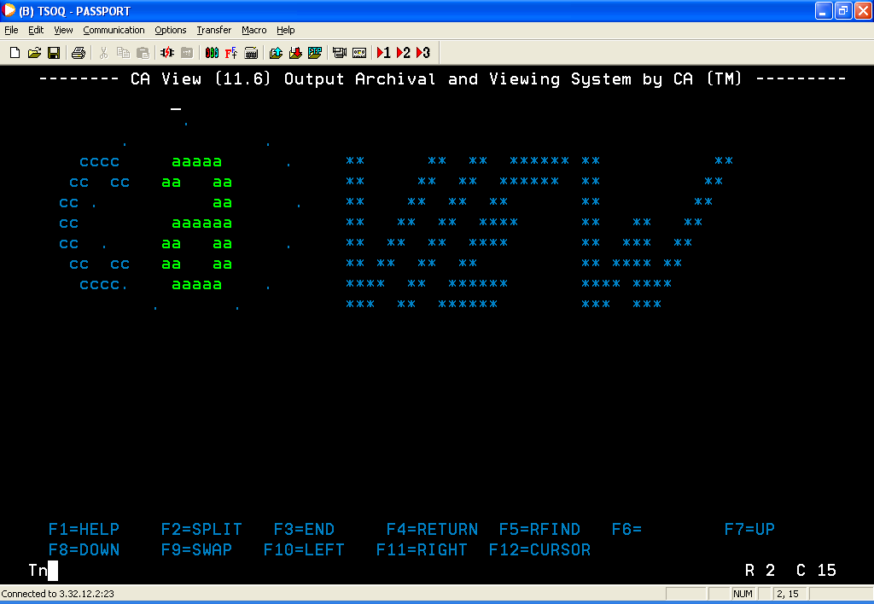

Press ‘ENTER’ again.

The following screen appears.

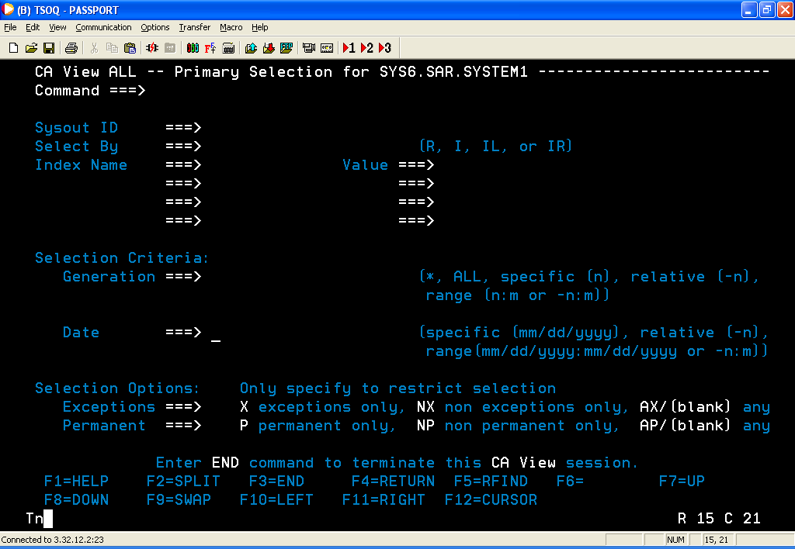

Step 3:

Enter the details as follows.

Job name for which you need to see the production output in ‘Sysout ID’

Give “**R”** in ‘Select By’

Give the date range in ‘Date’. The format should be **mm/dd/yyyy:mm/dd/yyyy**

Eg: 06/01/2012:08/27/2012 .

The following is an example for A0JCPES0 job where TAPE to TEMP(viewable version)

After entering the above said details the screen would be

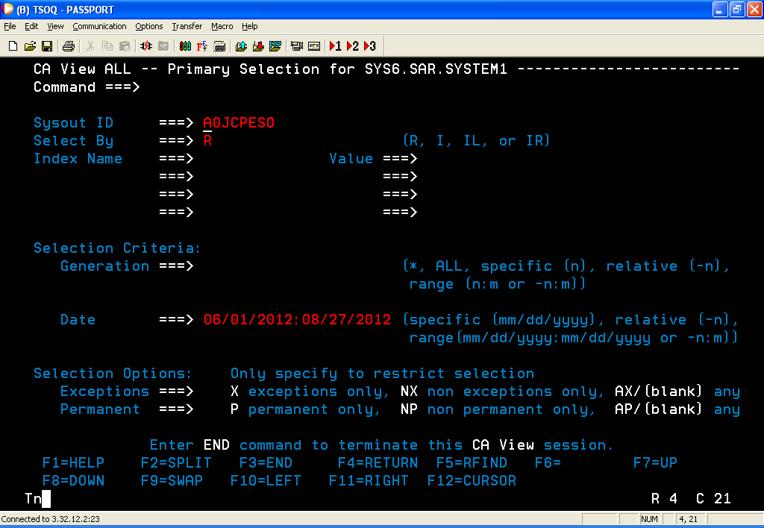

Press ‘ENTER’

Give “**S**” in ‘Sel’

We don’t have access to view the sysout that is in TAPE.

To convert this from TAPE to TAPE (viewable version),

Give “**L**” and press ‘ENTER’

***Note:*** Make sure to give 'S' before 'L' to confirm "No mount authority" is displayed first before submitting the job.

The following is an example for A0JCPES0 job where its sysout is in TAPE and has no mount authority.

JCL is created.

Give  **F3** 2 times.

Enter the Job card details to submit the job as per the following snapshot and press ‘Enter’

Sample:

//NKKN5GT1 JOB 30666,TESTING,

// CLASS=B,MSGCLASS=H,

// NOTIFY=&SYSUID

//*

The job is executed successfully.

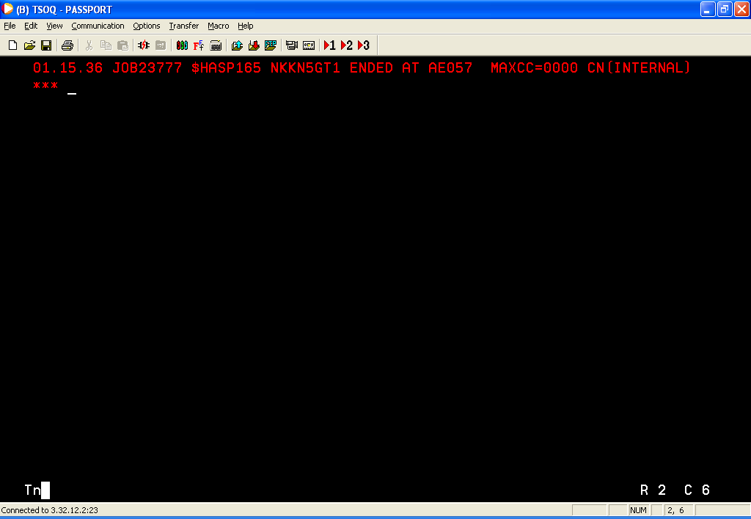

Again follow the same steps as that of **step3**.

The TAPE version is changed to TEMP version as shown below.

Now, the sysout can be viewed.

